Activity 3.4 Defending against infection

Notebook: Defending against infection
- List two barriers that prevent pathogens entering the human body and explain how they work.
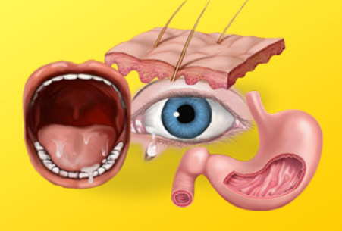
2. What is the role of the white blood cells called phagocytes in protecting us from disease?

3. Explain how the white blood cells called lymphocytes destroy pathogens that enter our blood.
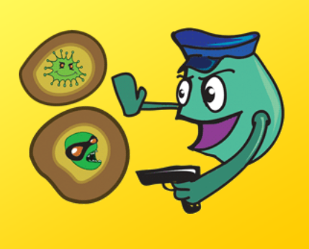
4. Do you know how the parts of the immune system work together to prevent disease? Make a concept map using the following terms:-
Lymphatic vessels
Lymph fluid
Thymus
White blood cells
Phagocytes
Lymphocytes
Spleen
Bone marrow
Lymph nodes

